School Year 2019-2020

Course Name | Personal Fitness | Course Code | 36.0510000
School Name | Stone Mountain High School | Teacher Name | Coach J.J. Oliver
School Phone Number | (678) 676-6302 | Teacher Email | James_Oliver@dekalbschoolsga.org
School Website | http://www.stonemountainhs.dekalb.k12.ga.us/ | Teacher Website

Curriculum Overview
The following academic concepts will be covered.

CURRICULUM OVERVIEW
Course Description:

High School students require Health, Personal Fitness, and 1 Elective PE Course to graduate. All courses are aligned with the Georgia Performance Standards. To measure the level of fitness, Physical Education students are required to participate in the FITNESSGRAM, which is a fitness assessment mandated by the Georgia Department of Education for all students participating in Physical Education K-12. The scores in the FITNESSGRAM are not part of the student’s overall Physical Education grade.

This course provides instruction in methods to attain a healthy level of physical fitness. It covers how to develop a lifetime fitness program based on a personal fitness assessment and stresses strength, muscular endurance, flexibility, body composition and cardiovascular endurance. Includes fitness principles, nutrition, fad diets, weight control, stress management, adherence strategies and consumer information; promotes self-awareness and responsibility for fitness. This course is a hybrid course which includes instruction and assessment in the classroom and through physical activity.

Students will:

- Understand the components of physical fitness and how they relate to overall physical
wellness
- Participate in fitness assessments that measure the components of physical fitness.
- Understand the concept of total wellness and how team sports / lifetime activities
contribute to emotional and physical wellness
- Demonstrate & apply appropriate safety practices, rules, and procedures in all physical
activities
- Demonstrate appropriate social and cooperative behaviors in all activities.
- Be able to identify community resources that can further expand personal interests in
lifetime / leisure sports

Objectives:
- Maintain appropriate levels of cardiovascular and respiratory efficiency,
muscular strength, endurance, flexibility and body composition necessary for a healthful lifestyle
- Use the results of fitness assessments to guide changes in the personal program
of each student
- To actively participate and learn aerobic exercises that will help students
improve lifetime fitness skills that will enable them to live a healthier lifestyle
- To actively participate and learn strength training exercises that will help
students learn lifetime fitness skills assisting them in creating a healthier
lifestyle

INSTRUCTIONAL MATERIALS
Title | Foundations of Personal Fitness
ISBN | 0-07-845127-2
Replacement Cost | N/A
Online book and/or resources | N/A
Online student access code (school specific) | N/A

GRADING SYSTEM: Grading:
Grades are based on effort, dressing out, cooperative participation, skill development, leadership qualities, writing assignments, quizzes, and tests. Other assignments may also impact your grade. Remember, this is a participation-based class, which means credit cannot be given for work not completed. YOU CAN ONLY MAKE
UP EXCUSED ABSENCES. School related absences will not affect your grade. Unexcused absences, tardy, or improper conduct cannot be made up. Remember, each person is important to the class in terms of social skills, teamwork, and other success factors.

Daily Grading Scale

Everyday students will receive a grade for dressing out and participation.
Students can earn 20 points for dressing out if they are fully prepared for class, dressed in PE uniform
Students can earn 20 points for participation if they completed all daily stretches and exercise, and fully participated in class.
Points will be Deducted for partially dressing out and or not participating fully.
Dressing Out includes the following: Black shorts or sweats and a white t-shirt.

GRADING CATEGORIES | *GRADE PROTOCOL
Formative Assessment - 0%  Assessment During Learning – 25%  (writing assignments, article critiques, classwork, daily participation)  Guided, Independent, or Group Practice – 45%  (daily dress out)  Summative Assessment or Assessment of Learning– 30%  (Tests) | A 90 – 100 ~P (pass)  B 80 – 89 ~F (fail)  C 71 – 79  D 70  F Below 70

Health and Physical Education K-12

 | _{Pass (100-70)} | _{Fail (69 – 0)}
_{Assessment During Learning}  - _{Cooperation in activities}  - _{Follows directions}  - _{Leadership/responsibility} | - Student cooperates appropriately in class activities without a reminder 70% or more of the time.  - Student listens and follows directions 70% or more of the time.  - Student demonstrates positive, responsible, personal and social behavior  (i.e. wearing appropriate footwear) 70% or more of the time. | - Student cooperates appropriately in class activities without a reminder less than 70% of the time.  - Student listens and follows directions less than 70% of the time.  - Student demonstrates positive, responsible, personal and social behavior  _{(i.e. wearing appropriate}  _{footwear) less than 70% of}  _{the time}
Guided, Independent, or Group Practice  - _{Respect people and equipment}  - _{Positive attitude}  - _{Rules/Safety} | - Student demonstrates appropriate behavior to others and equipment 70% or more of the time.  - Student exhibits a positive attitude toward task and others 70% or more of the time.  - Student follows class safety rules and treats equipment with care 70% or more of the time. | - Student demonstrates appropriate behavior to others and equipment less than 70% of the time.  - Student exhibits a positive attitude toward task and others less than 70% of the time.  - Student follows class safety rules and treats equipment with care less than 70% of the time.
Assessments to Validate Learning  - _{Observation of skills}  - _{Written tests}  - _{Accepts feedback} | - Student exhibits outstanding performance 70% or more of the time.  - Student demonstrates content knowledge of standards 70% or more of the time.  - Student accepts feedback from peers and teacher 70% or more of the time. | - Student exhibits outstanding performance less than 70% of the time.  - Student demonstrates content knowledge of standards less than 70% of the time.  - Student accepts feedback from peers and teacher less than 70% of the time.

DISTRICT EXPECTATIONS FOR SUCCESS
STUDENT PROGRESS | Semester progress reports shall be issued four and a half, nine and thirteen and a half weeks into each semester. The progress of students shall be evaluated frequently and plans shall be generated to remediate deficiencies as they are discovered. Plans shall include appropriate interventions designed to meet the needs of the students. See Board Policy IH.
ACADEMIC INTEGRITY | Students will not engage in an act of academic dishonesty including, but not limited to, cheating, providing false information, falsifying school records, forging signatures, or using an unauthorized computer user ID or password. See the Code of Student Conduct - Student Rights and Responsibilities and Character Development Handbook.
HOMEWORK | Homework assignments should be meaningful and should be an application or adaptation of a classroom experience. Homework is at all times an extension of the teaching/learning experience. It should be considered the possession of the student and should be collected, evaluated and returned to the students. See Board Policy IHB.
MAKE-UP WORK  DUE TO ABSENCES | All missed work and assessments are the responsibility of the student when they are absent from school. A student who is absent on the class day before a regularly scheduled assessment will be responsible for completing the assignment on the regularly scheduled day and time. The teacher has the discretion to grant a longer period of time to make up work if there are extenuating circumstances.
SCHOOL EXPECTATIONS FOR SUCCESS
CLASSROOM EXPECTATIONS | 1. The student will comply with the gymnasium rules of conduct and with the rules and regulations of the school as outlined in the Student Handbook.  2. GYM LOCKERS are to be used DURING ACTIVITY only. You are responsible for your personal belongings. DO NOT SHARE LOCKERS. BRING NO VALUABLES TO GYM. Use a combination lock. If lockers are used for permanent storage of personal belongings, locks may be sawed off and contents of lockers will be given or thrown away.  3. Students will have _5__ minutes from the 1st bell to report changed to their designated teacher's area. A student can be late twice to the same class. He/she has _5__ minutes to enter the gymnasium complex and another _5__ minutes to change for activity.  4. NO FOOD, GUM, OR DRINK in the gym at any time. ANY teacher WILL CONFISCATE any food or drink. It will not be returned. Practice SAFETY at all times..  5. NO CELL PHONES AND OTHER ELECTRONICS IN GYMNASIUM. NO BOOKBAGS IN GYMNASIUM.  6. A student must give a note signed by a parent (guardian) at the beginning of each class in which he/she is not participating. After the 3rd class, the students will be excused from class participation by a doctor's note ONLY. The doctor’s note will include the reason for non-participation and a date indicating the length of time of non-participation.  7. Students will not leave the class without permission and MUST have note if they leave gymnasium complex.
MATERIALS AND SUPPLIES | Students are required to follow SMHS Physical Education dress code.  All students should come to class appropriately dressed to participate in physical activity according to the PE Dress Code. PE dress attire will include the appropriate colored t-shirt or sweatshirt and shorts or sweatpants (See Dress Code Document Below). We will go outside during inclement weather so dress accordingly on those days. The most important required item of clothing is shoes. When we are in the gymnasium, please where basketball/tennis type shoes. When we are participating in field sports you may use rubber or plastic spiked shoes only. All students must bring a lock to class, which will be used to secure their belongings. Secure all personal items in the gym locker.
EXTRA HELP | Coaches are available after school for extra help in finishing assignments or making up workouts.
SECURITY | * P.E. Lockers are to be used at, “CLASS PERIOD ONLY. *LOCKERS MAY NOT BE  SHARED.  1. Do not tamper with or attempt to open any other locker.  2. Purchase your own lock.  3. Never give your combination to anyone, if you have a problem ask a teacher for help.  4. Before leaving the locker room for roll call check to make sure your lock is LOCKED.  5. DO NOT KEEP $$$ OR VALUABLES IN YOUR LOCKER.  6. Understand that you are responsible for your property so secure it.  7. Book bags are not allowed in the gym or locker room. Leave your book bag in your school locker and bring your changing clothes only to the gym areas. ALWAYS lock everything in a locker during class. DO NOT leave anything on the floor or on the bench.  8. Do not linger in the locker room. Be in roll call on time. Students are not allowed in the locker room without supervision. Doors will be locked during class time.  9. Electronic equipment of any kind is not allowed in the locker room or in class.  10. Flagrant disregard for locker room safety or security will result in loss of locker room privileges.  11. Access to the locker rooms is granted only during your class period during dress out and dress in time.

PHYSICAL EDUCATION DAILY RUBRICS
POINTS | 20 | 15 | 10 | 0
RESPONSIBILITY | - On time, in attendance spot  - Proper uniform  - Helps with set up & take down  - Uses equipment properly  - Stays in gym area until bell | - On time  - Change of clothes  - Helps with set up & take down  - Uses equipment properly  - Stays in gym area until bell | - Late for class but on time for attendance  - Missing some of uniform but has sneakers  - Sometimes helps with set up & take down  - Leaves gym before bell | - Late & misses attendance  - Missing some of uniform & does not have sneakers  - Never helps set up or take down equipment  - Misuses equipment  - Leaves gym before bell
EFFORT | - Executes warm-ups with high energy & superior form  - Gives top effort entire period  - Always on task, tries hard & works to improve skills | - Executes warm-ups with good energy & good form  - Gives good effort the entire class  - On task most of the time, tries hard & works to improve skills | - Executes warm-ups with low energy & lacks form  - Gives low effort the entire class  - Has to be told to keep on task, does little to improve skills | - Executes warm-ups with little or no energy & lacks form  - Gives low effort the entire class  - Very seldom on task & does little or nothing to improve skills
ATTITUDE | - Always enthusiastic  - Works cooperatively  - Displays good sportsmanship  - Respects authority, listens well  - No display of profanity  - Plays by the rules of the game & plays with safety for self & others in mind | - Enthusiastic most of the class  - Works cooperatively  - Displays good sportsmanship  - Respects authority, good listener  - No display of profanity  - Plays by the rules of the game, & plays with safety for self & others in mind | - Passive most of the class  - At times, works cooperatively  - Can be disagreeable  - Inattentive at times  - Little or no use of profanity  - Sometimes plays by the rules of the game, careless with safety for self & others | - Passive all class  - Does not work cooperatively  - Poor sportsmanship  - Talks when teacher is talking  - Displays profanity  - Disregards rules of the game, careless with safety for self & others  - Creates conflict
BONUS | - Shows positive leadership, takes extra time to help with equipment, & goes out of their way to help others | 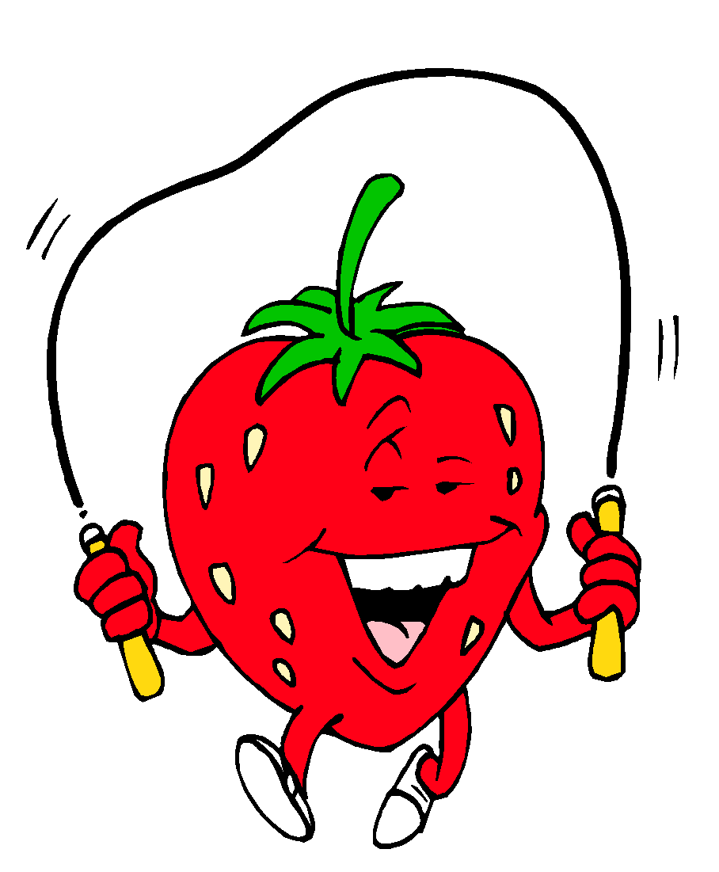

PLEASE SIGN BELOW AND RETURN

I have read the syllabus.

Student Signature___________________________________________________________

Parent/Guardian Signature____________________________________________________

Date_____________________________

Additional information to support continued contact:

Information | Parent/Guardian
Day Time Phone Number
Cellular Phone Number
Home Phone Number
Email Address

STONE MOUNTAIN HIGH SCHOOL
PERSONAL FITNESS DRESS CODE

The health and physical education department will be in compliance with the school uniform policy.

Colors: Black-Shorts/Sweatpants and White Shirt

Tops: Long or Short Sleeve
Bottom: Sweatpants, knee length shorts, joggers

Shoes: Tennis Shoes (no hard bottomed shoes or boots)
NONE OF THE FOLLOWING:
Spaghetti Strap Tops
Low Cut Shirts
Sleeveless Shirts
Tights
Yoga Pants
Tank Tops
Saggy Pants
Hard Bottom Shoes
Sandals
Slippers
Slides
Flip Flops

All Belongings must remain in the locker room No food, drinks, or cell phones are allowed in the gymnasium.

